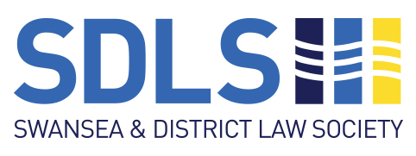
Booking Form
Swansea & District Law Society President’s Drinks Evening
at No Sign Wine Bar,
Wind Street, Swansea.

Friday 24th April 2026 – 5.30pm to 7.30pm

Tickets: £20

To reserve your tickets at this event, please complete this form and email it to:

olivia@bwl-law.co.uk

Please note that no actual tickets will be issued for the event.

Total number of member tickets required at £20 each:

I confirm payment of £ has been paid to the SDLS Bank account.

Bank: Barclays
Sort Code: 20-84-41
Account number: 10774871
Account name: Swansea & District Law Society
Reference: President’s Reception/[Firm Name]

Any Dietary Requirements:

Booking in the name of:

Organisation (if applicable):

Email address:

Contact telephone number:

If you require any further information, please email swanlawsoc@gmail.com

